**Ideation Phase**

**Define the Problem Statements**

|  |  |
| --- | --- |
| Date | 17 OCTOBER 2022 |
| Team ID | PNT2022TMID23778 |
| Project Name | Signs with Smart Connectivity for Better Road Safety |
| Maximum Marks | 2 Marks |

**Customer Problem Statement:**

Nowadays road signs and speed limits are static, road and speed limits can’t be changed in some cases. If We replace static signs with dynamic signs, the signs can be changed at anytime and anywhere. This project will replace the static boards to smart signed boards that will change the speed limits according to the weather climate and show diversion messages if there is accidents in the road and alerts messages if there is hospital, school or any roadworks.

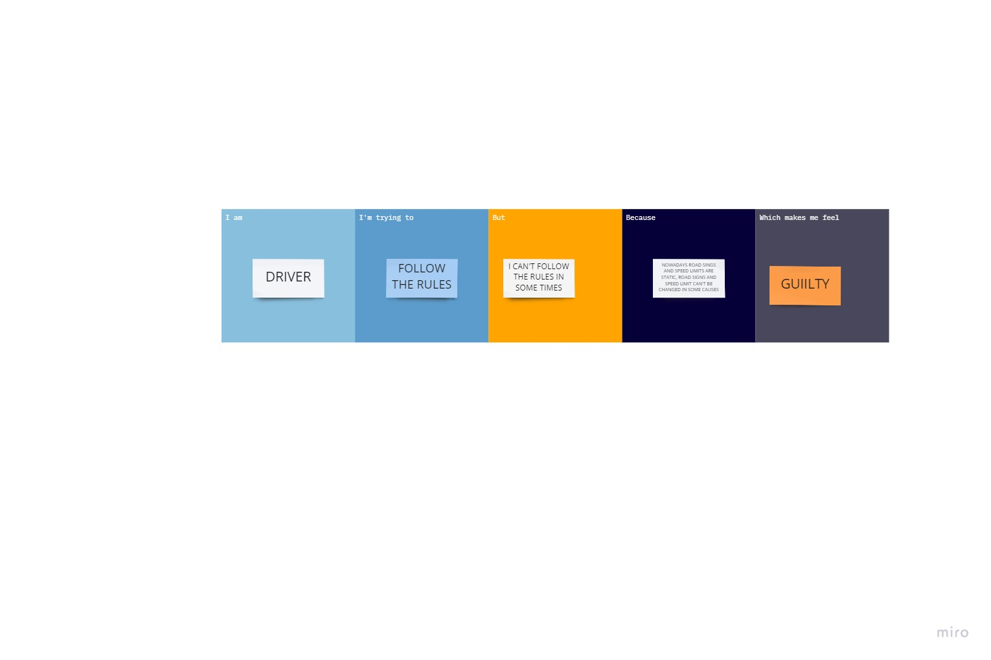

|  |  |  |  |  |  |
| --- | --- | --- | --- | --- | --- |
| **Problem Statement (PS)** | **I am (Customer)** | **I’m trying to** | **But** | **Because** | **Which makes me feel** |
| PS-1 | DRIVER | FOLLOW THE RULES | I CAN’T FOLLOW THE RULES IN SOME TIMES | NOWADAYS ROAD SIGNS AND SPEED LIMITS ARE STATIC | GUILTY |
| PS-2 | STUDENT | CROSS THE ROAD | I CAN’T CROSS THE ROAD EVEN AT THE RED LIGHT | THEY ARE URGE WITH THEIR WORK | SAD AND IRRITATING |